# InterApt Training

Project Based Learning

## Day 01

Certifications

* MTA - Python

Programs to Look up

* Visual Logic

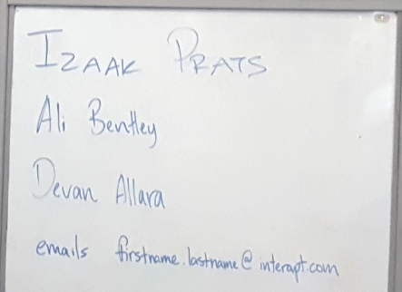

My goal in this training

* Learn how the curriculum is structured
* Learn what length of time is expected for this course
* Learn what others are doing that is successful

What are others doing?

* Mostly Python
* There are very few that do Visual Basic
* There are many that use Java
* There are some that use C#
* There is one that uses Visual Logic for teaching flowcharting

### Izaak Prats

* Loves Swift
* Lots of free resources
* Has the ability to use an iPad
* Scott U’Sellis added in there will soon be a course code for that
* A big bonus is the playground feature….whatever that is
* Someone compared it to Turtle Math

### Repl.it

* <https://repl.it/>
* 
* 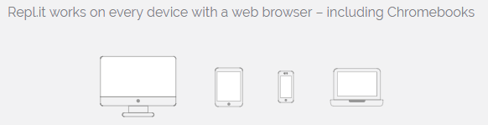
* Free for public schools

### Curriculum Concepts

* Get the students to go out and research concepts
* Let the course be facilitated not instructed
* This course is not intended to have specific lesson plans but instead let the students drive the curriculum based on their projects
* The main goal is have the students have full buy-in on their project and run on their own
* Again a major emphasis on being a facilitator not an instructor
  + Our goal is to guide them in how to find and use resources
  + Our goal is to create students who have intrinsic motivation to learn
  + ***Scott U’Sellis has offered to answer any questions about why we don’t have lesson plans***
* We will be the instructor for the first few weeks, but then the students take off on their own
  + Students should work in groups of at least 2 but not more than 3
* Interapt and KDE are developing a final exam
  + It’s not multiple choice
  + There will be a rubric before we start the course in August
  + They will turn in their final project on GitHub
  + They will also turn in a document that shows how it was developed
* Students should create an Gant chart
  + Each week they will turn in an update on how close to being on track they are
  + Provide code submissions that show progression in the project
  + Documentation of how they approached their problem and succeeded or failed
* An emphasis is being put on using called Slack
  + An industry standard tool that is used for communication
  + Email is secondary, Slack is primary
  + <https://slack.com/>
  + 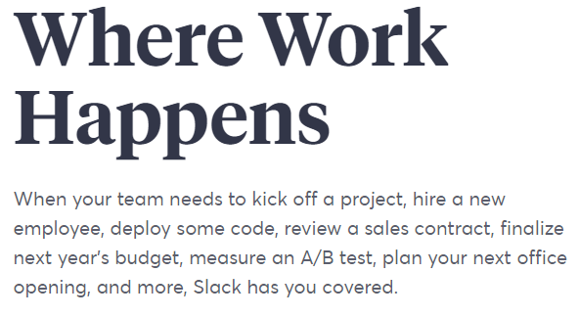
* The students need to get over the fear of failure
  + As a junior developer, most companies expect your fail miserably and often
  + They want to know if you are willing to learn, the research and to ask
  + They would rather hire someone that is willing and able to learn something new than someone who already knows how to do it

### Hack-a-thon

* What in the world is Hack-a-thon?
  + An event, typically lasting several days, in which a large number of people meet to engage in collaborative computer programming.
* Start with what is annoying to you
* Look at a much larger problem and break it down into smaller pieces
* Make up your own problems
  + If someone tweeted a bot on Twitter, that bot would combine some random capture and create a meme
* Solve community problems
* Consider things the students are passionate about or thing you really like to do

### Time for us to come up with a problem

* Lost and Found
  + Audio cords
  + Wal-Mart card
  + etc.
* Visual Base Numbering systems app
  + Like the manipulatives used in elementary schools
  + Ex: Base 3 – when you have 3 ones, you have a new block
* Tabletop Game Suggestion Bot
  + Based on other games you like, what games might you enjoy
  + Do we have it in our club
  + Cost, etc.
* PO Tracking System
  + Submit digitally
  + Bookkeeper check in
  + Principal approval status